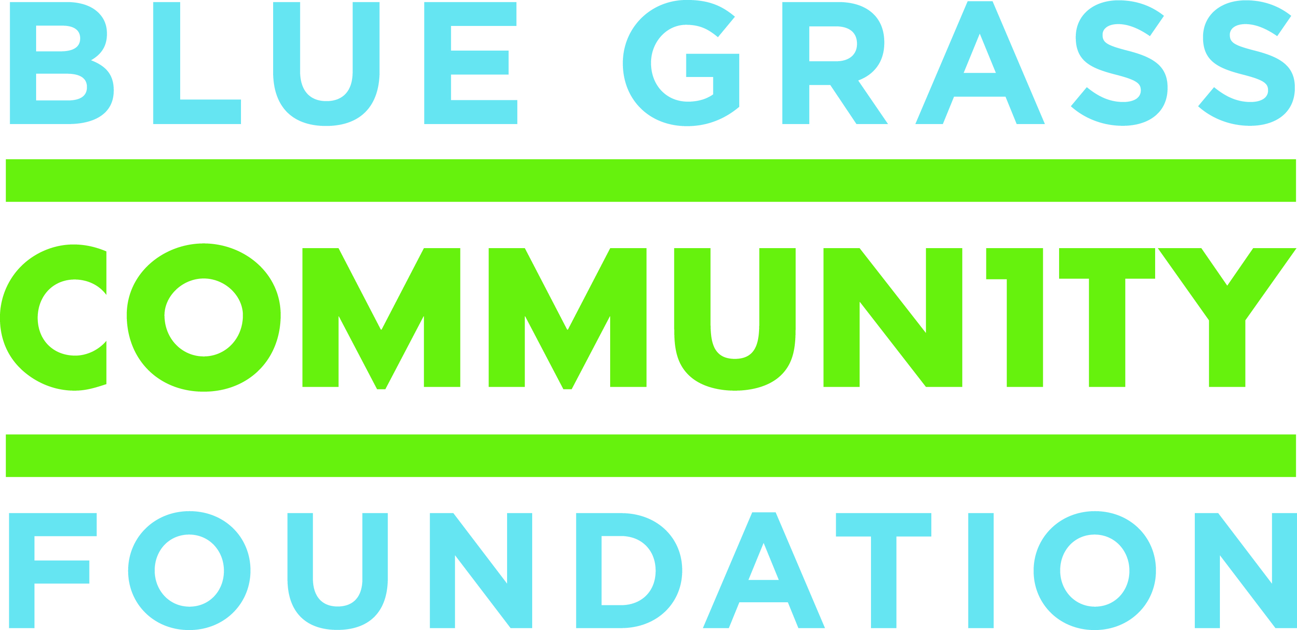
For Immediate Release
October 3, 2017
Contact:
Kristen Tidwell
859.225.3343 | kristen@bgcf.org

Hudson-Ellis Fund at Blue Grass Community Foundation Awards
more than $100,000 in Scholarships and Grants in 2017

In September, Blue Grass Community Foundation awarded more than $80,000 in grants to 18 charitable organizations for projects that will improve the quality of life for citizens in Boyle County. Organizations serving Boyle County applied for funding through the Hudson-Ellis Competitive Grantmaking Program, which is made possible by the generosity of Lottie B. Ellis whose bequest established endowments at Blue Grass Community Foundation.

Over the summer, the Hudson-Ellis Scholarship Fund awarded $30,000 in new and renewed college scholarships. Each year, renewable scholarships of $2,500 are awarded to one high school senior from Boyle County High School, Danville High School, and Kentucky School for the Deaf.

A lifelong Danville resident, Lottie Ellis had a passion for Boyle County which led her to establish a legacy gift when she passed away in 1999. As per Ms. Ellis’ wishes, Blue Grass Community Foundation established two permanent endowment funds: The Hudson-Ellis Discretionary Fund and the Hudson-Ellis Scholarship Fund. To date, he Hudson-Ellis Discretionary Fund has made150 grants to local nonprofit organizations totaling over $1 million and the Scholarship Fund has awarded 128 scholarships totaling almost $300,000.

John F. Joyner and Lena H. Joyner shared Ms. Ellis’ vision and their legacy endowment has helped fund the competitive grant program with more than $28,000 in grants to Boyle County nonprofits.

The 2017 Hudson-Ellis Scholarship award recipients are:

Tara Quesenberry – Boyle County High School
Alayna Wood – Danville High School
Allanah McBride – Kentucky School for the Deaf

A complete list of 2017 Hudson-Ellis Discretionary Grant Recipients appears below.

Arts Commission of Danville-Boyle County, Youth Art Fair Annual Exhibit

Assisting Deaf Adults to Participate Totally, Deaf Ed 2017-2018

Boyle County Education Foundation, Scholarships for Pre-School students

CASA of the Bluegrass, to train, recruit and supervise 10 additional CASA volunteers who will advocate for the best interest of abused and neglected children in the Boyle County Family Court System

Community Arts Center, arts field trips for students attending Danville Schools, Boyle County Schools, and Kentucky School for the Deaf

Danville Library, to create “Art Detective Crates” which will foster greater observational skills, collaboration, and problem solving skills while teaching local history

Danville Schools Education Foundation, Providing “Parents as Teacher” services to identified familes through “Cradle School” with the goal of strengthening families

Danville/Boyle County Happy Feet Equals Learning Feet, to purchase new shoes and socks for underprivileged children in Boyle County

Danville-Boyle County Senior Citizens, to help support free transportation provided to Boyle County Senior Citizens for activities of daily living, such as doctor appointments, trips to the pharmacy, etc.

Family Services Association of Boyle County, for emergency housing assistance for residents of Boyle County

The Gladys Project, to pay for background checks for volunteers who help children not enrolled in preschool prepare for kindergarten

Grace Café, to support the operating costs of the pay-what-you-can café

Heritage Hospice, to support the children’s bereavement camp

Kentucky School for the Deaf Charitable Foundation, to purchase a color printer and new literautre for the library

New Hope Food Pantry, to purchase food that is distributed free to Boyle County residents who are in need

Special Persons Advocacy Network (SPAN), Camp Hope 2018

Sunrise Children’s Services, to support families and children in crisis in Boyle County

Wilderness Trace Child Development Center, to create a much needed space to conduct student therapy

###

About Blue Grass Community Foundation
We are a public charity established by local citizens 50 years ago to promote giving and improve the quality of life in Lexington and the many communities we serve across Central and Appalachia Kentucky. We strive to make communities we serve the most vibrant, generous, and engaged places they can be for everyone. Since 1967, the Community Foundation has awarded more than $77.5 million in grant funding to thousands of organizations, including $9 million in FY2017. To learn more about Blue Grass Community Foundation, visit www.bgcf.org or contact President/CEO Lisa Adkins at 859.225.3343.

