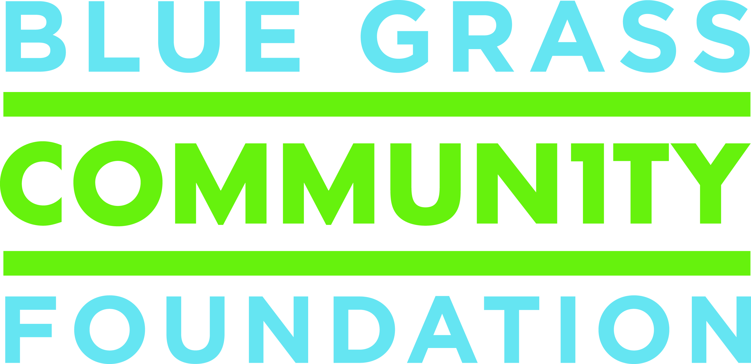
For Immediate Release
October 3, 2017

Contact:
Laurie Preston
859.721.2347 | laurie@bgcf.org

Blue Grass Community Foundation awards $100,000 to organizations focusing on literacy and early childhood education

Blue Grass Community Foundation awarded $100,000 to 13 nonprofit organizations serving Central Kentucky. Nonprofits applied for funding through a competitive grant-making program made possible by the MacAdam Early Childhood and Literacy Fund at the Community Foundation.

Below is a complete list of 2017 Early Childhood Education & Literacy grant recipients:

Blue Grass Farm Charities, Inc. – to support ESL classes for thoroughbred workers and their families

Bluegrass Council of the Blind – to help people with vision loss read again by using assistive devices

Carnegie Center for Literacy & Learning – to support Authors & Books for Kids, a free program for elementary-aged children that helps them discover a love of books and improve reading and writing skills

Common Good Community Development Corporation – to support a project celebrating diversity and different cultures through books, writing, and language literacy

Fayette County Public Schools – to expand the Lexington Reach Out and Read™ project by providing the book, I Love You like Sunshine, in Spanish and English to parents at their infant’s two-week check-up and to support the Read to Me Library program

Friends of Scott County Public Library – to support the Homework Help Club, which provides tutoring assistance for elementary school students during the academic year

Kentucky Refugee Ministries – to expand Limited English Proficiency learners’ access to preparatory courses for employment and higher education

Lexington Hearing and Speech Center – to support STEM based learning activities in preschool and kindgergarten classrooms to prepare students for academic success in elementary school

The Nest Center for Women, Children & Families – to increase the quality of learning in the Center’s free Childcare Program by investing in a curriculum that ecompasses best practices and aligns with the KY Early Childhood Learning Standards

Reading Camp – to support South Lexington/Nicholasville Reading Camp, a free literacy-focused summer camp that serves students who are at least one level below grade level

The Salvation Army – to enrich classrooms at the Salvation Army Early Learning Center with up-to-date educational technology

Visually Impaired Preschool Services – to support the in-home Direct Services Program for children birth to 3 years old and the Early Preschool center-based program for 3-4 year olds to assist children with visual impairments in reaching developmental milestones to prepare them educationally and socially to enter preschool and kindergarten

Woodford Educational Endowment Foundation – to support Woodford READS, a partnership with Woodford Public Schools, which provides a chapter book to every Woodford County student in grades PK-5, which will be the student’s to keep

###

About Blue Grass Community Foundation
We are a public charity established by local citizens 50 years ago to promote giving and improve the quality of life in Lexington and the many communities we serve across Central and Appalachia Kentucky. We strive to make communities we serve the most vibrant, generous, and engaged places they can be for everyone. Since 1967, the Community Foundation has awarded more than $77.5 million in grant funding to thousands of organizations, including $9 million in FY2017. To learn more about Blue Grass Community Foundation, visit www.bgcf.org or contact President/CEO Lisa Adkins at 859.225.3343.

